Contenido

1. Introducción 2

2. Objetivos Generales 3

3. Información Técnica 4

4. Involucrados 4

5. Funcionalidades 5

5.1 Solicitud Única de Vinculación y Productos 5

5.2 CRM 7

5.3 Estadísticas 9

6. Gestión de Usuarios 10

7. Puntos de acceso CRM Actual o antiguo 11

8. Espacios de nombre y clases (Controlador y Modelo) Antiguo 11

9. Diagrama de Base de Datos 12

10. Estructura de tablas 13

## Introducción

Este proyecto se desarrollará para mitigar las funcionalidades de Lupaap normal, pero en un entorno nuevo, debido a que el código muy extenso es causa de que los programadores no entiendan o se confundan y demoren al momento de desarrollar y entregar. Se tuvo en cuenta una nueva tecnología para ello.

## Objetivos Generales

Obtener un producto inicialmente, mínimo viable al pasar por control de calidad para posteriormente tener un producto terminado para el cliente. Y se puedan realizar los consumos de los Web Services requeridos entre ellos el Formulario de Vinculación de Productos, CRM y BPO. Además, se contará con un sistema de autenticación con token de seguridad encriptado en sha-1.

El desarrollador podrá desarrollar las Web Services y funcionalidades sin limitaciones de entornos y con un código más entendible con menor nivel de riesgo de impacto negativo en el software.

## Información Técnica

|  |  |
| --- | --- |
| Plataforma | Windows/Linux |
| Lenguaje de programación | JavaScript |
| Framework | Express Node JS 16.13.1 |
| Base de datos | MySQL Server 8 |

## Involucrados

|  |  |
| --- | --- |
| Juan David Alvarez | Gerente de proyectos (Creador) |
| Javier Cano | Gerente de desarrollo |
| Darvis Trillos Ariza | Desarrollador FullStack (Creador) |
| Oscar Herrera | Desarrollador Senior |

## Funcionalidades

### Solicitud Única de Vinculación y Productos

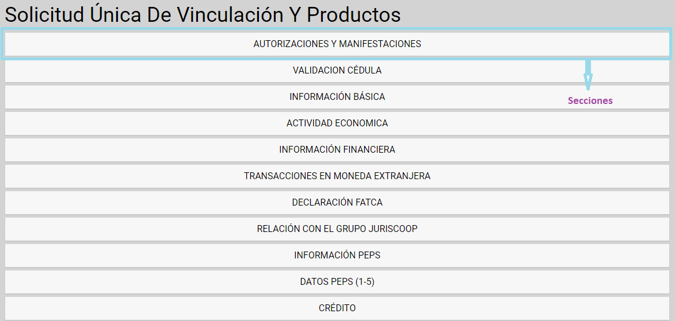

El de la figura anterior es un formulario que consta de unas secciones como se señala en la imagen en el formulario se ingresan una serie de registros con información básica y hasta empresarial de los clientes. Un ejemplo de una sección es VALIDACIÓN CEDULA:

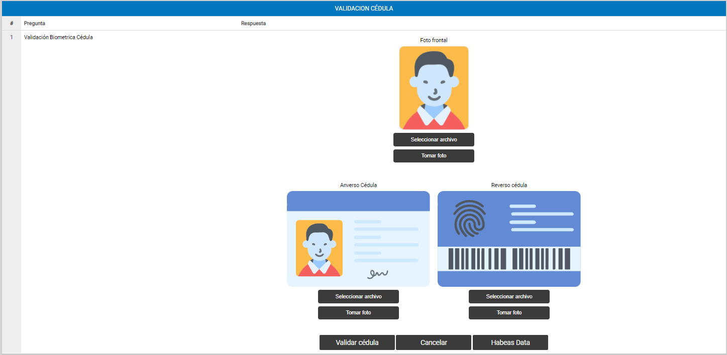

Al dar click en la sección VALIDACIÓN CEDULA se despliega la esta con título de la pregunta Validación Biométrica Cédula del formulario de Vinculación. La respuesta consta de una validación biométrica proveída por la empresa EasyBio se ingresan la foto tamaño documento, la foto de anverso de la cedula y la foto del reverso de la cedula. Al dar click en el botón Validar cedula, el resultado arroja todos los datos de la cedula en un arreglo Json y con el cual se llenan ciertos campos del formulario como son nombres, ciudad de expedición, fecha de expedición. Al llenar los campos requeridos del formulario y dar click en guardar se guarda en la base de datos todo lo introducido.

### CRM

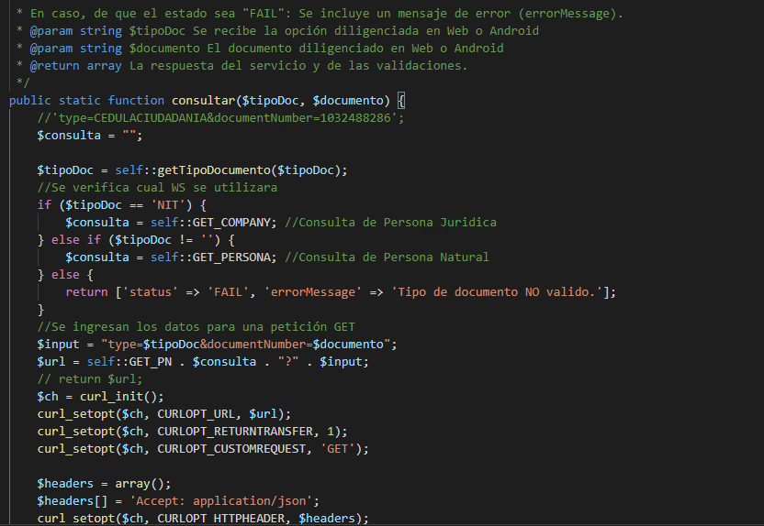

Es la Api que conecta una comunicación entre Lupaap y el software CRM de Juriscoop donde se consultan todas las propiedades del cliente persona natural o empresa como se muestra en el código de la imagen anterior donde la petición que es técnicamente HTTP POST he internamente se codifica como tipo get, así mismo también existen los puntos de acceso post para crear y actualizar como se evidencia en la siguiente imagen:

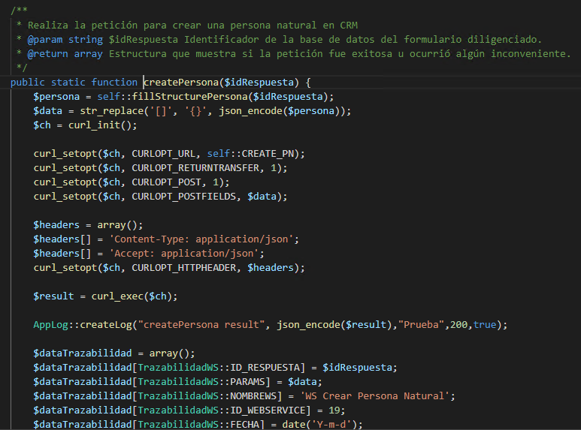

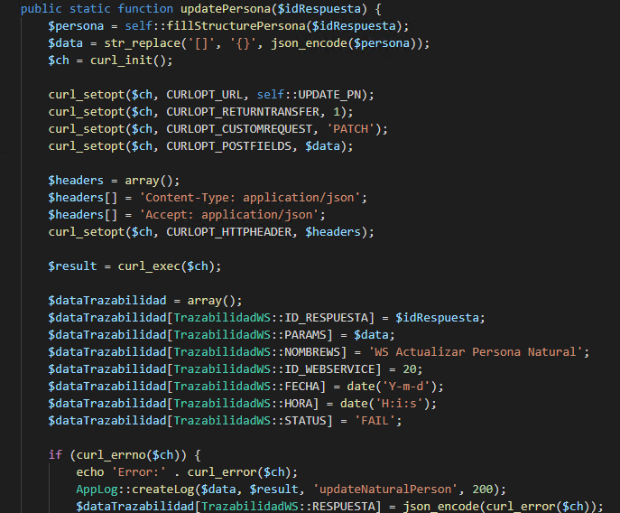

Lo anterior es a nivel de código puesto que son servicios del Back-End que se pueden consumir desde cualquier software y es lo que va a ser implementado en Lupaap Light.

### Estadísticas

Esta funcionalidad servirá para la realizar toma de decisiones atreves de los reportes e informes que se muestran en el ejemplo a continuación:

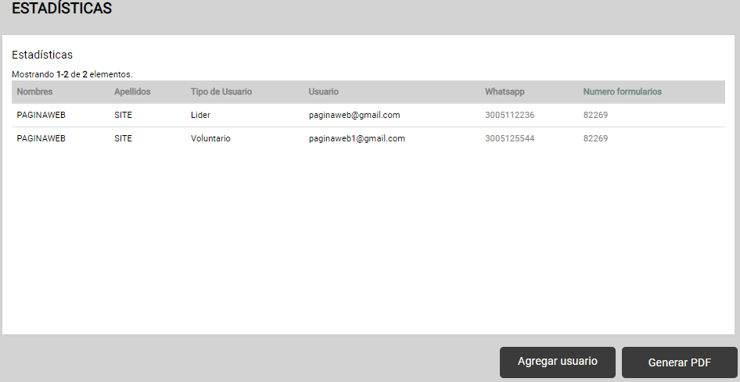

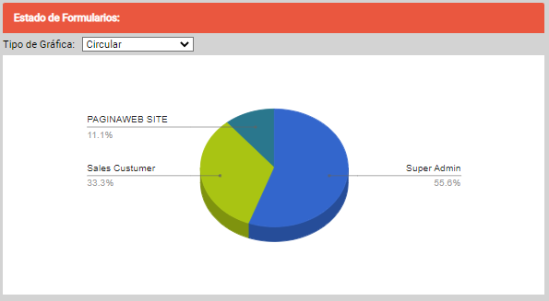

## Gestión de Usuarios

Es un crud para la creación y parametrización de los usuarios también tendrán propiedades a través de tablas auxiliares que sirven para definir un tipo de usuario y la definición de un rol para ingresar al dashboard desde un front-end. Un ejemplo a continuación.

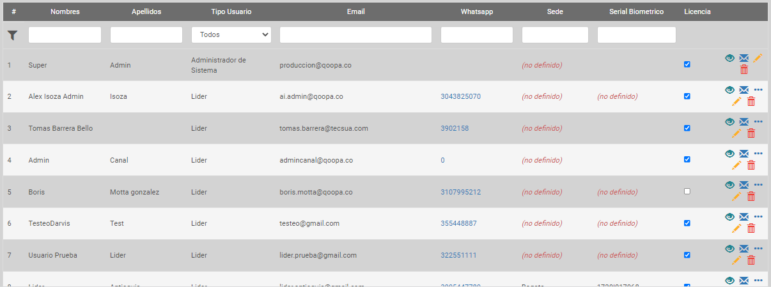

## Puntos de acceso CRM Actual o antiguo

Crear Persona o Empresa: <http://34.75.180.168/lupaaplight/lupaap/www/api/juriscoop/crear-persona>

Se envían un parámetro formdata llamado idRespuesta, es la respuesta del formulario que guardaba.

Actualizar Persona o Empresa: <http://34.75.180.168/lupaaplight/lupaap/www/api/juriscoop/actualizar-persona>

Igual que la creación.

Consultar: <http://34.75.180.168/lupaaplight/lupaap/www/api/juriscoop/get-persona>

Se envían dos parámetros formdata llamados numeroIdentificacion y tipoIdentificacion, del cliente creado en el CRM.

## Espacios de nombre y clases (Controlador y Modelo) Antiguo

NameSpace: LupaapApi\Controllers

Clases: IntegracionJuriscoopController.php

NameSpace: LupaapApi\Modules\Juriscoop

Clases: ConsultaPersonaEmpresa.php (Modelo)

## Diagrama de Base de Datos

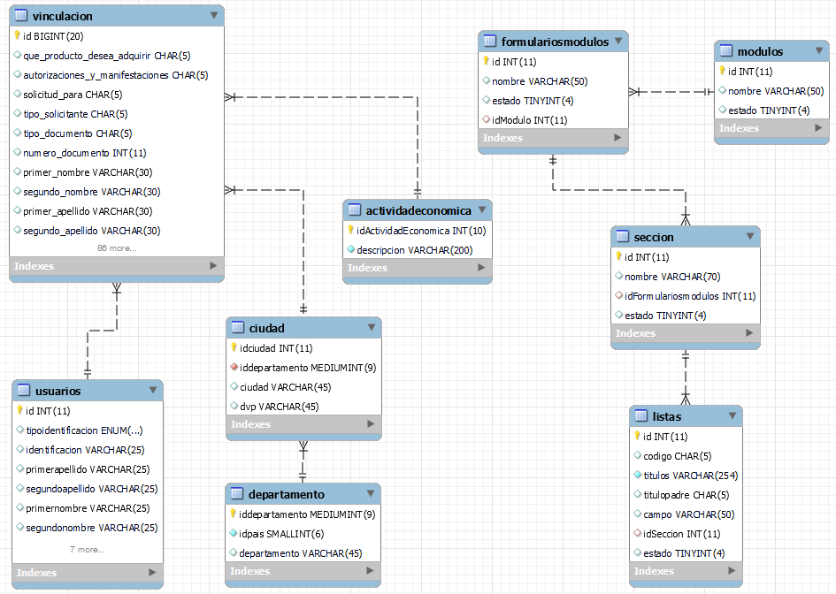

## Estructura de tablas

|  |
| --- |
| **Lupaap Light DB Struct** |

* actividadeconomica
* ciudad
* departamento
* formulariosmodulos
* listas
* modulos
* seccion
* usuarios
* vinculacion

|  |  |
| --- | --- |
| **actividadeconomica** |  |
|  |  |

|  |
| --- |
| **Fields** |

|  |  |  |  |  |  |  |  |  |
| --- | --- | --- | --- | --- | --- | --- | --- | --- |
| **Field** | **Type** | **Collation** | **Null** | **Key** | **Default** | **Extra** | **Privileges** | **Comment** |
| idActividadEconomica | int(10) unsigned | (NULL) | NO | PRI | (NULL) |  | select,insert,update,references |  |
| descripcion | varchar(200) | utf8_general_ci | NO |  | (NULL) |  | select,insert,update,references |  |

|  |
| --- |
| **Indexes** |

|  |  |  |  |  |  |  |  |  |  |  |  |  |
| --- | --- | --- | --- | --- | --- | --- | --- | --- | --- | --- | --- | --- |
| **Table** | **Non unique** | **Key name** | **Seq in index** | **Column name** | **Collation** | **Cardinality** | **Sub part** | **Packed** | **Null** | **Index type** | **Comment** | **Index comment** |
| actividadeconomica | 0 | PRIMARY | 1 | idActividadEconomica | A | 725 | (NULL) | (NULL) |  | BTREE |  |  |
| actividadeconomica | 0 | idActividadEconomica_UNIQUE | 1 | idActividadEconomica | A | 725 | (NULL) | (NULL) |  | BTREE |  |  |

Back

|  |  |
| --- | --- |
| **ciudad** |  |
|  |  |

|  |
| --- |
| **Fields** |

|  |  |  |  |  |  |  |  |  |
| --- | --- | --- | --- | --- | --- | --- | --- | --- |
| **Field** | **Type** | **Collation** | **Null** | **Key** | **Default** | **Extra** | **Privileges** | **Comment** |
| idciudad | int(11) | (NULL) | NO | PRI | (NULL) | auto_increment | select,insert,update,references |  |
| iddepartamento | mediumint(9) | (NULL) | NO | MUL | (NULL) |  | select,insert,update,references |  |
| ciudad | varchar(45) | utf8_general_ci | YES |  | (NULL) |  | select,insert,update,references |  |
| dvp | varchar(45) | utf8_general_ci | YES |  | (NULL) |  | select,insert,update,references |  |

|  |
| --- |
| **Indexes** |

|  |  |  |  |  |  |  |  |  |  |  |  |  |
| --- | --- | --- | --- | --- | --- | --- | --- | --- | --- | --- | --- | --- |
| **Table** | **Non unique** | **Key name** | **Seq in index** | **Column name** | **Collation** | **Cardinality** | **Sub part** | **Packed** | **Null** | **Index type** | **Comment** | **Index comment** |
| ciudad | 0 | PRIMARY | 1 | idciudad | A | 1119 | (NULL) | (NULL) |  | BTREE |  |  |
| ciudad | 1 | iddepartamento | 1 | iddepartamento | A | 373 | (NULL) | (NULL) |  | BTREE |  |  |

|  |
| --- |
| **Foreign Key Relationships** |

|  |  |  |  |  |
| --- | --- | --- | --- | --- |
| **FK Id** | **Reference Table** | **Source Column** | **Target Column** | **Extra Info** |
| ciudad_ibfk_1 | departamento | `iddepartamento` | `iddepartamento` |  |
|  |  |  |  |  |

Back

|  |  |
| --- | --- |
| **departamento** |  |
|  |  |

|  |
| --- |
| **Fields** |

|  |  |  |  |  |  |  |  |  |
| --- | --- | --- | --- | --- | --- | --- | --- | --- |
| **Field** | **Type** | **Collation** | **Null** | **Key** | **Default** | **Extra** | **Privileges** | **Comment** |
| iddepartamento | mediumint(9) | (NULL) | NO | PRI | (NULL) | auto_increment | select,insert,update,references |  |
| idpais | smallint(6) | (NULL) | NO |  | (NULL) |  | select,insert,update,references |  |
| departamento | varchar(45) | utf8_general_ci | YES |  | (NULL) |  | select,insert,update,references |  |

|  |
| --- |
| **Indexes** |

|  |  |  |  |  |  |  |  |  |  |  |  |  |
| --- | --- | --- | --- | --- | --- | --- | --- | --- | --- | --- | --- | --- |
| **Table** | **Non unique** | **Key name** | **Seq in index** | **Column name** | **Collation** | **Cardinality** | **Sub part** | **Packed** | **Null** | **Index type** | **Comment** | **Index comment** |
| departamento | 0 | PRIMARY | 1 | iddepartamento | A | 34 | (NULL) | (NULL) |  | BTREE |  |  |

Back

|  |  |
| --- | --- |
| **formulariosmodulos** |  |
|  |  |

|  |
| --- |
| **Fields** |

|  |  |  |  |  |  |  |  |  |
| --- | --- | --- | --- | --- | --- | --- | --- | --- |
| **Field** | **Type** | **Collation** | **Null** | **Key** | **Default** | **Extra** | **Privileges** | **Comment** |
| id | int(11) | (NULL) | NO | PRI | (NULL) | auto_increment | select,insert,update,references |  |
| nombre | varchar(50) | utf8_general_ci | YES |  | (NULL) |  | select,insert,update,references |  |
| estado | tinyint(4) | (NULL) | YES |  | (NULL) |  | select,insert,update,references |  |
| idModulo | int(11) | (NULL) | YES | MUL | (NULL) |  | select,insert,update,references |  |

|  |
| --- |
| **Indexes** |

|  |  |  |  |  |  |  |  |  |  |  |  |  |
| --- | --- | --- | --- | --- | --- | --- | --- | --- | --- | --- | --- | --- |
| **Table** | **Non unique** | **Key name** | **Seq in index** | **Column name** | **Collation** | **Cardinality** | **Sub part** | **Packed** | **Null** | **Index type** | **Comment** | **Index comment** |
| formulariosmodulos | 0 | PRIMARY | 1 | id | A | 0 | (NULL) | (NULL) |  | BTREE |  |  |
| formulariosmodulos | 1 | idModulo | 1 | idModulo | A | 0 | (NULL) | (NULL) | YES | BTREE |  |  |

|  |
| --- |
| **Foreign Key Relationships** |

|  |  |  |  |  |
| --- | --- | --- | --- | --- |
| **FK Id** | **Reference Table** | **Source Column** | **Target Column** | **Extra Info** |
| formulariosmodulos_ibfk_1 | modulos | `idModulo` | `id` |  |
|  |  |  |  |  |

Back

|  |  |
| --- | --- |
| **listas** |  |
|  |  |

|  |
| --- |
| **Fields** |

|  |  |  |  |  |  |  |  |  |
| --- | --- | --- | --- | --- | --- | --- | --- | --- |
| **Field** | **Type** | **Collation** | **Null** | **Key** | **Default** | **Extra** | **Privileges** | **Comment** |
| id | int(11) | (NULL) | NO | PRI | (NULL) | auto_increment | select,insert,update,references |  |
| codigo | char(5) | utf8_general_ci | YES |  | (NULL) |  | select,insert,update,references |  |
| titulos | varchar(254) | utf8_general_ci | NO |  | (NULL) |  | select,insert,update,references |  |
| titulopadre | char(5) | utf8_general_ci | YES |  | (NULL) |  | select,insert,update,references |  |
| campo | varchar(50) | utf8_general_ci | YES |  | (NULL) |  | select,insert,update,references |  |
| idSeccion | int(11) | (NULL) | YES | MUL | (NULL) |  | select,insert,update,references |  |
| estado | tinyint(4) | (NULL) | YES |  | (NULL) |  | select,insert,update,references |  |

|  |
| --- |
| **Indexes** |

|  |  |  |  |  |  |  |  |  |  |  |  |  |
| --- | --- | --- | --- | --- | --- | --- | --- | --- | --- | --- | --- | --- |
| **Table** | **Non unique** | **Key name** | **Seq in index** | **Column name** | **Collation** | **Cardinality** | **Sub part** | **Packed** | **Null** | **Index type** | **Comment** | **Index comment** |
| listas | 0 | PRIMARY | 1 | id | A | 10 | (NULL) | (NULL) |  | BTREE |  |  |
| listas | 1 | idSeccion | 1 | idSeccion | A | 5 | (NULL) | (NULL) | YES | BTREE |  |  |

|  |
| --- |
| **Foreign Key Relationships** |

|  |  |  |  |  |
| --- | --- | --- | --- | --- |
| **FK Id** | **Reference Table** | **Source Column** | **Target Column** | **Extra Info** |
| listas_ibfk_1 | seccion | `idSeccion` | `id` |  |
|  |  |  |  |  |

Back

|  |  |
| --- | --- |
| **modulos** |  |
|  |  |

|  |
| --- |
| **Fields** |

|  |  |  |  |  |  |  |  |  |
| --- | --- | --- | --- | --- | --- | --- | --- | --- |
| **Field** | **Type** | **Collation** | **Null** | **Key** | **Default** | **Extra** | **Privileges** | **Comment** |
| id | int(11) | (NULL) | NO | PRI | (NULL) | auto_increment | select,insert,update,references |  |
| nombre | varchar(50) | utf8_general_ci | YES |  | (NULL) |  | select,insert,update,references |  |
| estado | tinyint(4) | (NULL) | YES |  | (NULL) |  | select,insert,update,references |  |

|  |
| --- |
| **Indexes** |

|  |  |  |  |  |  |  |  |  |  |  |  |  |
| --- | --- | --- | --- | --- | --- | --- | --- | --- | --- | --- | --- | --- |
| **Table** | **Non unique** | **Key name** | **Seq in index** | **Column name** | **Collation** | **Cardinality** | **Sub part** | **Packed** | **Null** | **Index type** | **Comment** | **Index comment** |
| modulos | 0 | PRIMARY | 1 | id | A | 0 | (NULL) | (NULL) |  | BTREE |  |  |

Back

|  |  |
| --- | --- |
| **seccion** |  |
|  |  |

|  |
| --- |
| **Fields** |

|  |  |  |  |  |  |  |  |  |
| --- | --- | --- | --- | --- | --- | --- | --- | --- |
| **Field** | **Type** | **Collation** | **Null** | **Key** | **Default** | **Extra** | **Privileges** | **Comment** |
| id | int(11) | (NULL) | NO | PRI | (NULL) | auto_increment | select,insert,update,references |  |
| nombre | varchar(70) | utf8_general_ci | YES |  | (NULL) |  | select,insert,update,references |  |
| idFormulariosmodulos | int(11) | (NULL) | YES | MUL | (NULL) |  | select,insert,update,references |  |
| estado | tinyint(4) | (NULL) | YES |  | (NULL) |  | select,insert,update,references |  |

|  |
| --- |
| **Indexes** |

|  |  |  |  |  |  |  |  |  |  |  |  |  |
| --- | --- | --- | --- | --- | --- | --- | --- | --- | --- | --- | --- | --- |
| **Table** | **Non unique** | **Key name** | **Seq in index** | **Column name** | **Collation** | **Cardinality** | **Sub part** | **Packed** | **Null** | **Index type** | **Comment** | **Index comment** |
| seccion | 0 | PRIMARY | 1 | id | A | 14 | (NULL) | (NULL) |  | BTREE |  |  |
| seccion | 1 | idFormulariosmodulos | 1 | idFormulariosmodulos | A | 2 | (NULL) | (NULL) | YES | BTREE |  |  |

|  |
| --- |
| **Foreign Key Relationships** |

|  |  |  |  |  |
| --- | --- | --- | --- | --- |
| **FK Id** | **Reference Table** | **Source Column** | **Target Column** | **Extra Info** |
| seccion_ibfk_1 | formulariosmodulos | `idFormulariosmodulos` | `id` |  |
|  |  |  |  |  |

Back

|  |  |
| --- | --- |
| **usuarios** |  |
|  |  |

|  |
| --- |
| **Fields** |

|  |  |  |  |  |  |  |  |  |
| --- | --- | --- | --- | --- | --- | --- | --- | --- |
| **Field** | **Type** | **Collation** | **Null** | **Key** | **Default** | **Extra** | **Privileges** | **Comment** |
| id | int(11) | (NULL) | NO | PRI | (NULL) | auto_increment | select,insert,update,references |  |
| tipoidentificacion | enum('CC','CE','PASS','TI') | utf8_general_ci | YES | MUL | (NULL) |  | select,insert,update,references |  |
| identificacion | varchar(25) | utf8_general_ci | YES |  | (NULL) |  | select,insert,update,references |  |
| primerapellido | varchar(25) | utf8_general_ci | YES | MUL | (NULL) |  | select,insert,update,references |  |
| segundoapellido | varchar(25) | utf8_general_ci | YES |  | (NULL) |  | select,insert,update,references |  |
| primernombre | varchar(25) | utf8_general_ci | YES |  | (NULL) |  | select,insert,update,references |  |
| segundonombre | varchar(25) | utf8_general_ci | YES |  | (NULL) |  | select,insert,update,references |  |
| correo | varchar(70) | utf8_general_ci | YES | UNI | (NULL) |  | select,insert,update,references |  |
| celular | varchar(13) | utf8_general_ci | YES | UNI | (NULL) |  | select,insert,update,references |  |
| direccion | varchar(100) | utf8_general_ci | YES |  | (NULL) |  | select,insert,update,references |  |
| contrasena | varchar(250) | utf8_general_ci | YES |  | (NULL) |  | select,insert,update,references |  |
| fecha_creado | timestamp | (NULL) | YES |  | CURRENT_TIMESTAMP |  | select,insert,update,references |  |
| fecha_actualizado | timestamp | (NULL) | YES |  | CURRENT_TIMESTAMP |  | select,insert,update,references |  |
| estado | tinyint(4) | (NULL) | YES | MUL | 1 |  | select,insert,update,references |  |

|  |
| --- |
| **Indexes** |

|  |  |  |  |  |  |  |  |  |  |  |  |  |
| --- | --- | --- | --- | --- | --- | --- | --- | --- | --- | --- | --- | --- |
| **Table** | **Non unique** | **Key name** | **Seq in index** | **Column name** | **Collation** | **Cardinality** | **Sub part** | **Packed** | **Null** | **Index type** | **Comment** | **Index comment** |
| usuarios | 0 | PRIMARY | 1 | id | A | 1 | (NULL) | (NULL) |  | BTREE |  |  |
| usuarios | 0 | IDENT | 1 | tipoidentificacion | A | 1 | (NULL) | (NULL) | YES | BTREE |  |  |
| usuarios | 0 | IDENT | 2 | identificacion | A | 1 | (NULL) | (NULL) | YES | BTREE |  |  |
| usuarios | 0 | CORREO | 1 | correo | A | 1 | (NULL) | (NULL) | YES | BTREE |  |  |
| usuarios | 0 | NOMBRE | 1 | primerapellido | A | 1 | (NULL) | (NULL) | YES | BTREE |  |  |
| usuarios | 0 | NOMBRE | 2 | segundoapellido | A | 1 | (NULL) | (NULL) | YES | BTREE |  |  |
| usuarios | 0 | NOMBRE | 3 | primernombre | A | 1 | (NULL) | (NULL) | YES | BTREE |  |  |
| usuarios | 0 | NOMBRE | 4 | segundonombre | A | 1 | (NULL) | (NULL) | YES | BTREE |  |  |
| usuarios | 0 | CEL | 1 | celular | A | 1 | (NULL) | (NULL) | YES | BTREE |  |  |
| usuarios | 1 | ESTADO | 1 | estado | A | 1 | (NULL) | (NULL) | YES | BTREE |  |  |

Back

|  |  |
| --- | --- |
| **vinculacion** |  |
|  |  |

|  |
| --- |
| **Fields** |

|  |  |  |  |  |  |  |  |  |
| --- | --- | --- | --- | --- | --- | --- | --- | --- |
| **Field** | **Type** | **Collation** | **Null** | **Key** | **Default** | **Extra** | **Privileges** | **Comment** |
| id | bigint(20) | (NULL) | NO | PRI | (NULL) | auto_increment | select,insert,update,references |  |
| que_producto_desea_adquirir | char(5) | utf8_general_ci | YES |  | (NULL) |  | select,insert,update,references |  |
| autorizaciones_y_manifestaciones | char(5) | utf8_general_ci | YES |  | (NULL) |  | select,insert,update,references |  |
| solicitud_para | char(5) | utf8_general_ci | YES |  | (NULL) |  | select,insert,update,references |  |
| tipo_solicitante | char(5) | utf8_general_ci | YES |  | (NULL) |  | select,insert,update,references |  |
| tipo_documento | char(5) | utf8_general_ci | YES | MUL | (NULL) |  | select,insert,update,references |  |
| numero_documento | int(11) | (NULL) | YES |  | (NULL) |  | select,insert,update,references |  |
| primer_nombre | varchar(30) | utf8_general_ci | YES | MUL | (NULL) |  | select,insert,update,references |  |
| segundo_nombre | varchar(30) | utf8_general_ci | YES |  | (NULL) |  | select,insert,update,references |  |
| primer_apellido | varchar(30) | utf8_general_ci | YES | MUL | (NULL) |  | select,insert,update,references |  |
| segundo_apellido | varchar(30) | utf8_general_ci | YES |  | (NULL) |  | select,insert,update,references |  |
| genero | char(5) | utf8_general_ci | YES |  | (NULL) |  | select,insert,update,references |  |
| fecha_nacimiento | date | (NULL) | YES |  | (NULL) |  | select,insert,update,references |  |
| fecha_expedicion | date | (NULL) | YES |  | (NULL) |  | select,insert,update,references |  |
| tipo_documento_rl | char(5) | utf8_general_ci | YES |  | (NULL) |  | select,insert,update,references |  |
| direccion_residencia | varchar(100) | utf8_general_ci | YES |  | (NULL) |  | select,insert,update,references |  |
| telefono_residencia | int(11) | (NULL) | YES |  | (NULL) |  | select,insert,update,references |  |
| idCiudad | int(11) | (NULL) | YES | MUL | (NULL) |  | select,insert,update,references |  |
| estrato | char(5) | utf8_general_ci | YES |  | (NULL) |  | select,insert,update,references |  |
| celular | int(11) | (NULL) | YES |  | (NULL) |  | select,insert,update,references |  |
| correo | varchar(100) | utf8_general_ci | YES |  | (NULL) |  | select,insert,update,references |  |
| correo_adicional | varchar(100) | utf8_general_ci | YES |  | (NULL) |  | select,insert,update,references |  |
| envio_correspondencia | char(5) | utf8_general_ci | YES |  | (NULL) |  | select,insert,update,references |  |
| estado_civil | char(5) | utf8_general_ci | YES |  | (NULL) |  | select,insert,update,references |  |
| nivel_educacion | char(5) | utf8_general_ci | YES |  | (NULL) |  | select,insert,update,references |  |
| tipo_vivienda | char(5) | utf8_general_ci | YES |  | (NULL) |  | select,insert,update,references |  |
| personas_a_cargo | tinyint(4) | (NULL) | YES |  | (NULL) |  | select,insert,update,references |  |
| numero_documento_rl | int(11) | (NULL) | YES |  | (NULL) |  | select,insert,update,references |  |
| id_ciudad_expedicion | int(11) | (NULL) | YES |  | (NULL) |  | select,insert,update,references |  |
| id_ciudad_nacimiento | int(11) | (NULL) | YES |  | (NULL) |  | select,insert,update,references |  |
| ocupacion | char(5) | utf8_general_ci | YES |  | (NULL) |  | select,insert,update,references |  |
| cargo_oficio | char(5) | utf8_general_ci | YES |  | (NULL) |  | select,insert,update,references |  |
| tipo_contrato | char(5) | utf8_general_ci | YES |  | (NULL) |  | select,insert,update,references |  |
| nombre_empresa | varchar(100) | utf8_general_ci | YES |  | (NULL) |  | select,insert,update,references |  |
| direccion_laboral | varchar(100) | utf8_general_ci | YES |  | (NULL) |  | select,insert,update,references |  |
| id_ciudad_laboral | char(5) | utf8_general_ci | YES |  | (NULL) |  | select,insert,update,references |  |
| telfono_laboral | int(11) | (NULL) | YES |  | (NULL) |  | select,insert,update,references |  |
| ext_telefono_laboral | int(11) | (NULL) | YES |  | (NULL) |  | select,insert,update,references |  |
| fecha_ingreso_laboral | date | (NULL) | YES |  | (NULL) |  | select,insert,update,references |  |
| id_ciiu | int(11) unsigned | (NULL) | YES | MUL | (NULL) |  | select,insert,update,references |  |
| nicho_mercado | char(5) | utf8_general_ci | YES |  | (NULL) |  | select,insert,update,references |  |
| salario_pension | double | (NULL) | YES |  | (NULL) |  | select,insert,update,references |  |
| otros_ingresos | double | (NULL) | YES |  | (NULL) |  | select,insert,update,references |  |
| activos | double | (NULL) | YES |  | (NULL) |  | select,insert,update,references |  |
| paivos | double | (NULL) | YES |  | (NULL) |  | select,insert,update,references |  |
| descripcion_otros_ingresos | varchar(100) | utf8_general_ci | YES |  | (NULL) |  | select,insert,update,references |  |
| total_egresos_mensuales | double | (NULL) | YES |  | (NULL) |  | select,insert,update,references |  |
| productos_caja_juriscoop | char(5) | utf8_general_ci | YES |  | (NULL) |  | select,insert,update,references |  |
| productos_libranza_juriscoop | char(5) | utf8_general_ci | YES |  | (NULL) |  | select,insert,update,references |  |
| segmento | char(5) | utf8_general_ci | YES |  | (NULL) |  | select,insert,update,references |  |
| total_endeudamiento_financiera | double | (NULL) | YES |  | (NULL) |  | select,insert,update,references |  |
| otras_deducciones | double | (NULL) | YES |  | (NULL) |  | select,insert,update,references |  |
| producto_moneda_extranjera | char(5) | utf8_general_ci | YES |  | (NULL) |  | select,insert,update,references |  |
| tipo_moneda | char(5) | utf8_general_ci | YES |  | (NULL) |  | select,insert,update,references |  |
| transacciones | char(5) | utf8_general_ci | YES |  | (NULL) |  | select,insert,update,references |  |
| origen_fondos | char(5) | utf8_general_ci | YES |  | (NULL) |  | select,insert,update,references |  |
| obligado_tributar_eeuu | char(5) | utf8_general_ci | YES |  | (NULL) |  | select,insert,update,references |  |
| nacionalidad | char(5) | utf8_general_ci | YES |  | (NULL) |  | select,insert,update,references |  |
| numero_itin | int(11) | (NULL) | YES |  | (NULL) |  | select,insert,update,references |  |
| numero_telefono_eeuu | bigint(20) | (NULL) | YES |  | (NULL) |  | select,insert,update,references |  |
| direccion_eeuu | varchar(100) | utf8_general_ci | YES |  | (NULL) |  | select,insert,update,references |  |
| permanencia_ultimos_meses_eeuu | char(5) | utf8_general_ci | YES |  | (NULL) |  | select,insert,update,references |  |
| poseedor_tarjeta_verde_eeuu | char(5) | utf8_general_ci | YES |  | (NULL) |  | select,insert,update,references |  |
| recibi_pagos_eeuu | char(5) | utf8_general_ci | YES |  | (NULL) |  | select,insert,update,references |  |
| recibi_ingresos_ventas_eeuu | char(5) | utf8_general_ci | YES |  | (NULL) |  | select,insert,update,references |  |
| tiene_auto_certificacion_no | char(5) | utf8_general_ci | YES |  | (NULL) |  | select,insert,update,references |  |
| empresa_grupo_socio | char(5) | utf8_general_ci | YES |  | (NULL) |  | select,insert,update,references |  |
| nombres_apellidos | varchar(100) | utf8_general_ci | YES |  | (NULL) |  | select,insert,update,references |  |
| parentesco_socio_grupo | char(5) | utf8_general_ci | YES |  | (NULL) |  | select,insert,update,references |  |
| vinculacion_propiedad_entidades | char(5) | utf8_general_ci | YES |  | (NULL) |  | select,insert,update,references |  |
| nit_empresa | varchar(15) | utf8_general_ci | YES |  | (NULL) |  | select,insert,update,references |  |
| familiar_directivo | char(5) | utf8_general_ci | YES |  | (NULL) |  | select,insert,update,references |  |
| expuesto_publicamente | char(5) | utf8_general_ci | YES |  | (NULL) |  | select,insert,update,references |  |
| nombre_apellidos_pariente | varchar(100) | utf8_general_ci | YES |  | (NULL) |  | select,insert,update,references |  |
| parentesco | char(5) | utf8_general_ci | YES |  | (NULL) |  | select,insert,update,references |  |
| tipo_documento_pariente | char(5) | utf8_general_ci | YES |  | (NULL) |  | select,insert,update,references |  |
| numero_documento_pariente | varchar(25) | utf8_general_ci | YES |  | (NULL) |  | select,insert,update,references |  |
| telefono_celular_pariente | varchar(15) | utf8_general_ci | YES |  | (NULL) |  | select,insert,update,references |  |
| correo_pariente | varchar(100) | utf8_general_ci | YES |  | (NULL) |  | select,insert,update,references |  |
| forma_pago | char(5) | utf8_general_ci | YES |  | (NULL) |  | select,insert,update,references |  |
| entidad_desembolso | char(5) | utf8_general_ci | YES |  | (NULL) |  | select,insert,update,references |  |
| numero_cuenta | varchar(25) | utf8_general_ci | YES |  | (NULL) |  | select,insert,update,references |  |
| tipo_cuenta | char(5) | utf8_general_ci | YES |  | (NULL) |  | select,insert,update,references |  |
| nombres_apellidos_referencia | varchar(100) | utf8_general_ci | YES |  | (NULL) |  | select,insert,update,references |  |
| correo_referencia | varchar(100) | utf8_general_ci | YES |  | (NULL) |  | select,insert,update,references |  |
| tipo_referencia | char(5) | utf8_general_ci | YES |  | (NULL) |  | select,insert,update,references |  |
| celular_referencia | varchar(15) | utf8_general_ci | YES |  | (NULL) |  | select,insert,update,references |  |
| declara_impuestos_afuera | char(5) | utf8_general_ci | YES |  | (NULL) |  | select,insert,update,references |  |
| paises_numero_uno | char(5) | utf8_general_ci | YES |  | (NULL) |  | select,insert,update,references |  |
| paises_numero_dos | char(5) | utf8_general_ci | YES |  | (NULL) |  | select,insert,update,references |  |
| tin_no_1 | varchar(50) | utf8_general_ci | YES |  | (NULL) |  | select,insert,update,references |  |
| tin_no_2 | varchar(50) | utf8_general_ci | YES |  | (NULL) |  | select,insert,update,references |  |
| tin_no_1_nodisponible | char(5) | utf8_general_ci | YES |  | (NULL) |  | select,insert,update,references |  |
| tin_no_2_nodisponible | char(5) | utf8_general_ci | YES |  | (NULL) |  | select,insert,update,references |  |
| idUsuario | int(8) | (NULL) | YES | MUL | (NULL) |  | select,insert,update,references |  |
| fecha_creacion | timestamp | (NULL) | YES |  | CURRENT_TIMESTAMP |  | select,insert,update,references |  |
| estado | int(11) | (NULL) | YES |  | 1 |  | select,insert,update,references |  |

|  |
| --- |
| **Indexes** |

|  |  |  |  |  |  |  |  |  |  |  |  |  |
| --- | --- | --- | --- | --- | --- | --- | --- | --- | --- | --- | --- | --- |
| **Table** | **Non unique** | **Key name** | **Seq in index** | **Column name** | **Collation** | **Cardinality** | **Sub part** | **Packed** | **Null** | **Index type** | **Comment** | **Index comment** |
| vinculacion | 0 | PRIMARY | 1 | id | A | 0 | (NULL) | (NULL) |  | BTREE |  |  |
| vinculacion | 0 | IDENTIFICACION | 1 | tipo_documento | A | 0 | (NULL) | (NULL) | YES | BTREE |  |  |
| vinculacion | 0 | IDENTIFICACION | 2 | numero_documento | A | 0 | (NULL) | (NULL) | YES | BTREE |  |  |
| vinculacion | 0 | nombrecompleto | 1 | primer_nombre | A | 0 | (NULL) | (NULL) | YES | BTREE |  |  |
| vinculacion | 0 | nombrecompleto | 2 | segundo_nombre | A | 0 | (NULL) | (NULL) | YES | BTREE |  |  |
| vinculacion | 0 | nombrecompleto | 3 | primer_apellido | A | 0 | (NULL) | (NULL) | YES | BTREE |  |  |
| vinculacion | 0 | nombrecompleto | 4 | segundo_apellido | A | 0 | (NULL) | (NULL) | YES | BTREE |  |  |
| vinculacion | 1 | PAPE | 1 | primer_apellido | A | 0 | (NULL) | (NULL) | YES | BTREE |  |  |
| vinculacion | 1 | idUsuarios | 1 | idUsuario | A | 0 | (NULL) | (NULL) | YES | BTREE |  |  |
| vinculacion | 1 | idCiudad | 1 | idCiudad | A | 0 | (NULL) | (NULL) | YES | BTREE |  |  |
| vinculacion | 1 | idCiiu | 1 | id_ciiu | A | 0 | (NULL) | (NULL) | YES | BTREE |  |  |

|  |
| --- |
| **Foreign Key Relationships** |

|  |  |  |  |  |
| --- | --- | --- | --- | --- |
| **FK Id** | **Reference Table** | **Source Column** | **Target Column** | **Extra Info** |
| vinculacion_ibfk_1 | ciudad | `idCiudad` | `idciudad` | , |
|  |  |  |  |  |
| vinculacion_ibfk_2 | usuarios | `idUsuario` | `id` | , |
|  |  |  |  |  |
| vinculacion_ibfk_3 | actividadeconomica | `id_ciiu` | `idActividadEconomica` |  |
|  |  |  |  |  |

Back